Lab 2 – Wave Kinematics and Data Analysis – Irregular Waves

James Frizzell

OCEN 410 – Dr. Kuang

23 February 2022

# **Introduction:**

The ocean environment is dominated by complex wave dynamics, which cannot be simply modelled using previously studied Linear Wave Theory. In this laboratory experiment, multiple sets of irregular wave trains were generated at the Offshore Technology Research Center (OTRC), and the free surface elevation collected with capacitance-type wave probes. Four total wave trains were produced. Two of these mimicked the conditions of a 100-year return perid winter storm in the Gulf of Mexico, and the other two were described by the 1000-year hurricane conditions in the Gulf of Mexico. This data was analyzed using zero-upcrossing methods to determine the generated significant wave height, wave period, and power spectrum. These values were compared with their theoretical counterparts as defined by the Joint North Sea Wave Project (JONSWAP) equations. Equation 1 describes the power spectrum, while equations 2 and 3 are used to determine the significant wave height from the distribution of power.

|  |  |
| --- | --- |
| $$S\left(f\right)=AH_{s}^{2}T_{p}^{-4}f^{-5}*e^{\left(-1.25*{\left(T_{p}f\right)}^{-4}\right)}*γ^{e^{B}}$$ | (1) |
| $$A=\frac{0.0624}{0.23+0.0336γ-0.185{(1.9+γ)}^{-1}}$$ |  |
| $$B=\frac{-{(T_{p}f-1)}^{2}}{2σ^{2}}$$ |  |
| $$σ=\left(\begin{matrix}0.07 & when f<f_{p} \\ 0.09 & when f≥f_{p}\end{matrix}\right)$$ |  |
| $$γ=peakedness (constant)$$ |  |
| $$M_{0}=\int{S\left(f\right)df}=σ^{2}$$ | (2) |
| $$H_{s}=4σ$$ | (3) |

# **Methodology:**

To complete this experiment, a 3-Dimensional wave tank was used. A capacitance wave probe was calibrated and set up over the deepest part of the OTRC tank to minimize any shallow-water effects. A DAQ system was used to capture the wave height data. The OTRC basin uses 48 individually controllable wave flaps, each powered by a hydraulic system to generate waves. The waves propagate towards the wave absorber, which dissipates the wave energy to prevent the effects of wave reflection during tests.

A computer software is used to convert input data into controller commands which direct the motion of the wave flaps. The two different wave trains produced in this lab were fed to the computer, and resulting 100-year and 1000-year storm conditions were generated. The JONSWAP spectrum parameters for the two datasets are summarized in Table 1.

Table 1: Spectrum parameters for the different wave trains.

|  |  |  |
| --- | --- | --- |
|  | 100-year Storm | 1000-year Hurricane |
| Significant Wave Height (m) | 9.0 | 20.0 |
| Significant Wave Period (s) | 11.9 | 17.3 |
| Peakedness value | 1.0 | 2.4 |

# **Results:**

The raw data collected from the four wave trains was plotted and inspected visually to ensure that the appropriate wave heights were recorded for each test. Figure 1 and Figure 2 graph the free surface elevation for the 100-year storm conditions. Figure 3 and Figure 4 show the free surface elevation for the 1000-year hurricane conditions. Referring back to Table 1, the significant wave height of the 100-year storms should be 9.0 meters, and the 1000-year hurricane should be 20.0 m. The graphs generally agree with these numbers, as only 1 wave from the first wave train exceeded the 9.0 meter value, and no waves from the second wave train exceeded the 20.0 meter value.

Figure 1: Wave surface elevation for the 10-year storm conditions during trial 1.

Figure 2: Wave surface elevation for the 100-year storm conditions during trial 2

Figure 3: Wave surface elevation for the 1000-year hurricane conditions during trial 1

Figure 4: Wave surface elevation for the 1000-year hurricane conditions during trial 2

The issue with representing long time series this way is that it requires a large amount of data to accurately represent a given wave pattern. As the time axis extends towards infinity, the computational power necessary to perform analyses grows. This is why spectral representations are commonly used – they transform data with a possibly infinite time axis into a frequency domain, where the maximum values lie in a small range.

The JONSWAP Spectrum, as defined in Equation 1, describes the amount of wave energy in certain bandwidths. Figure 5, Figure 6, Figure 7, and Figure 8 show the spectral representations of each wave train. Because the data is very noisy, a moving average considering the 20 nearest measurements is plotted alongside the raw data.

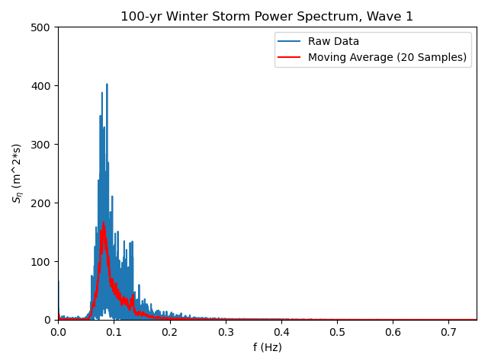

Figure 5: Power spectrum for 100-year storm, trail 1. A moving average with P=20 is shown to display a better trend of the line.

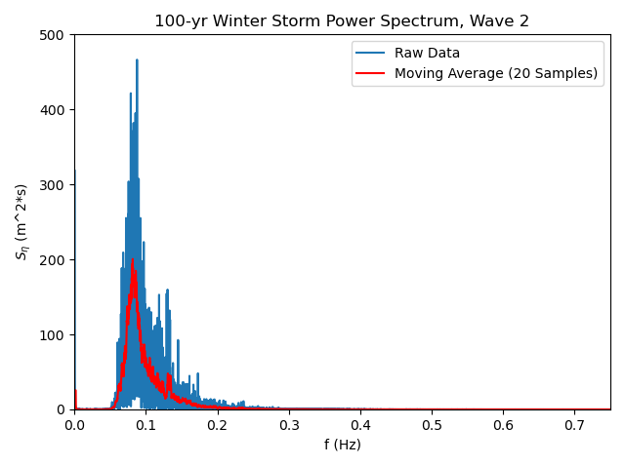

Figure 6: Power spectrum for 100-year storm, trail 2. A moving average with P=20 is shown to display a better trend of the line.

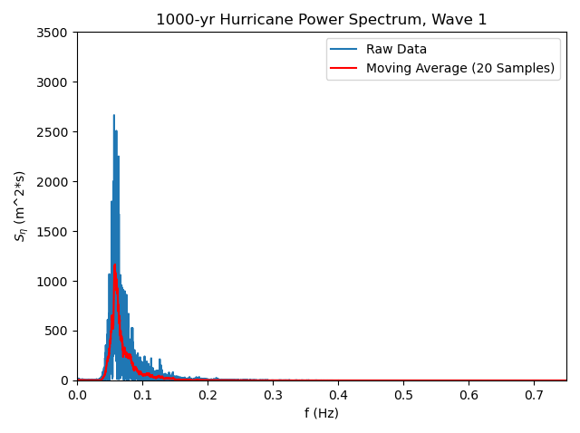

Figure 7: Power spectrum for 1000-year hurricane, trail 1. A moving average with P=20 is shown to display a better trend of the line.

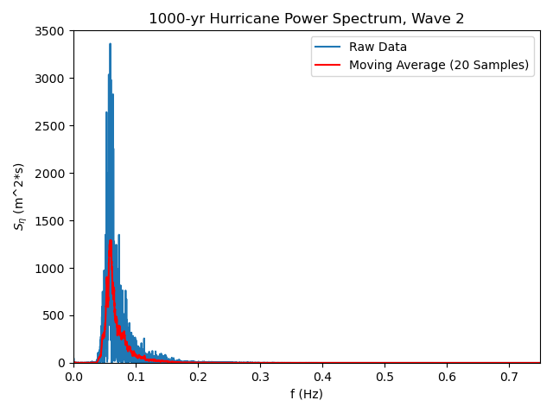

Figure 8: Power spectrum for 1000-year hurricane, trail 1. A moving average with P=20 is shown to display a better trend of the line.

With the spectrum representations of the raw data created, a comparison between the generated waves and theoretical spectrum. The theoretical spectrum was defined by Equation 1.

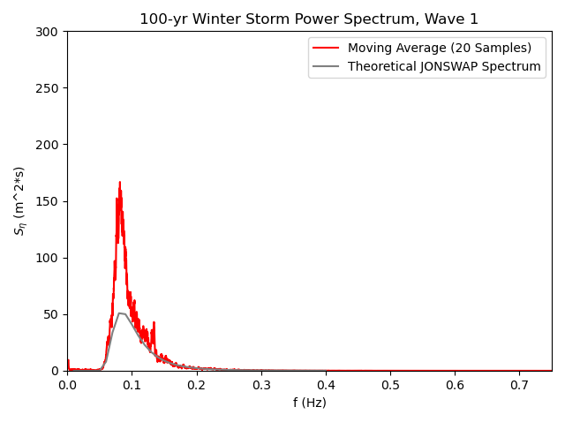

Figure 9: Comparison between the generated spectrum from the first trial of the 100-year storm and the theoretical JONSWAP spectrum. The produced wave has a much higher peak than the JONSWAP spectrum

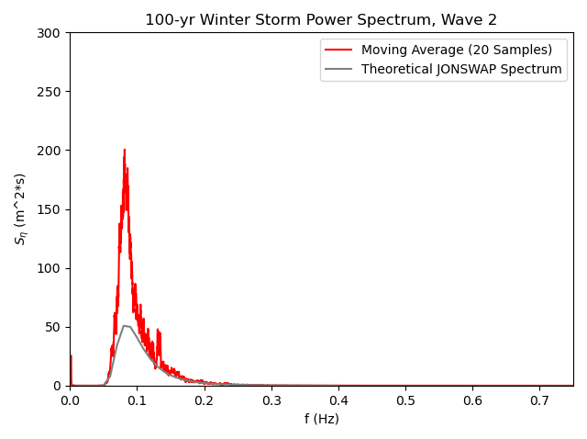

Figure 10: Comparison between the generated spectrum from the second trial of the 100-year storm and the theoretical JONSWAP spectrum. The produced wave has a much higher peak than the JONSWAP spectrum

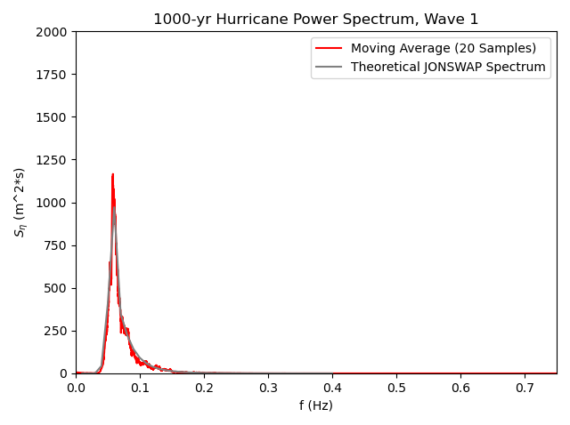

Figure 11: Comparison between the generated spectrum from the first trial of the 1000-year hurricane and the theoretical JONSWAP spectrum. There is almost no difference between the two lines.

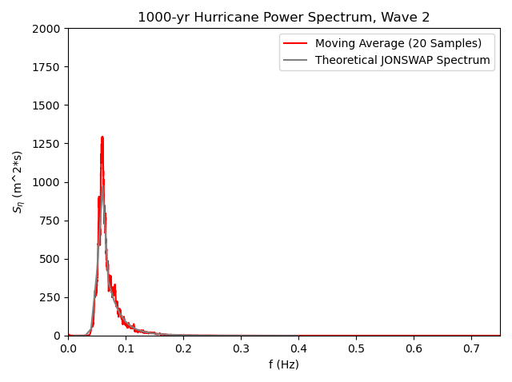

Figure 12: Comparison between the generated spectrum from the second trial of the 1000-year hurricane and the theoretical JONSWAP spectrum. There is almost no difference between the two lines.

Another area of interest of the wave spectra are the distributions of wave height and wave period. Figure 13, Figure 14, Figure 15, and Figure 16

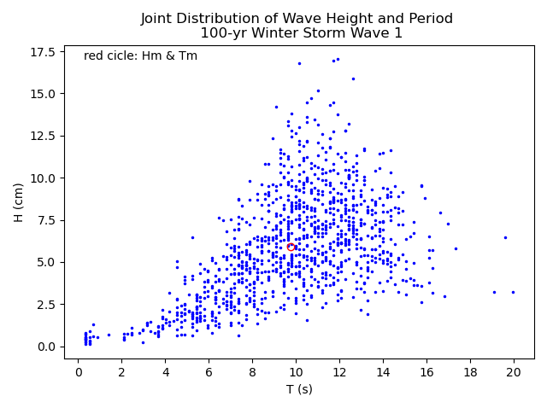

Figure 13: Wave height plotted against wave period for the first trial of the 100-year storm. Both quantities were calculated using a zero-upcrossing technique.

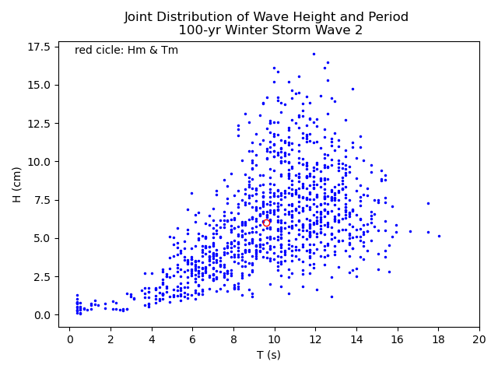

Figure 14: Wave height plotted against wave period for the first trial of the 100-year storm. Both quantities were calculated using a zero-upcrossing technique.

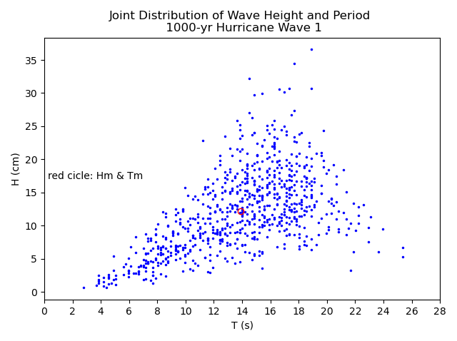

Figure 15: Wave height plotted against wave period for the first trial of the 100-year storm. Both quantities were calculated using a zero-upcrossing technique.

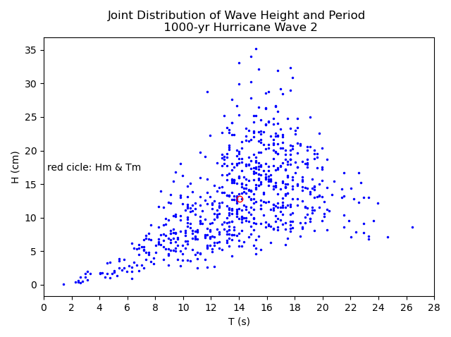

Figure 16: Wave height plotted against wave period for the first trial of the 100-year storm. Both quantities were calculated using a zero-upcrossing technique.

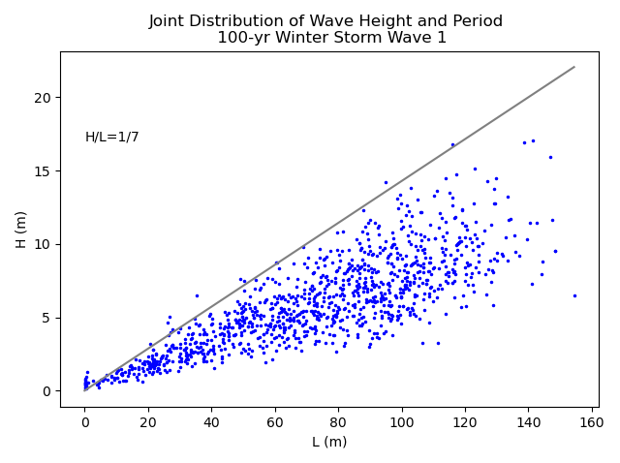

Figure 17: Wave height plotted against wavelength. Wavelength was calculated using the linear dispersion relationship with the values of T and H from Figure 13.

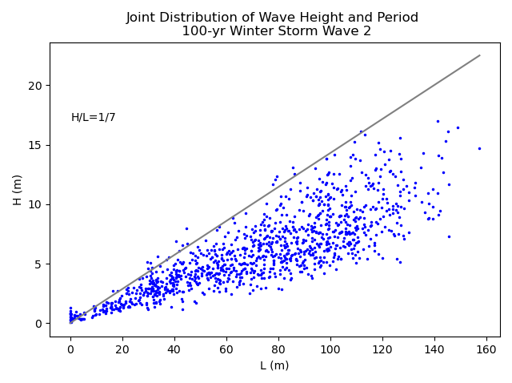

Figure 18: Wave height plotted against wavelength. Wavelength was calculated using the linear dispersion relationship with the values of T and H from Figure 14.

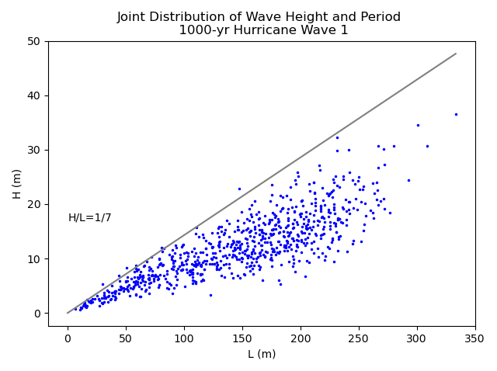

Figure 19: Wave height plotted against wavelength. Wavelength was calculated using the linear dispersion relationship with the values of T and H from Figure 15.

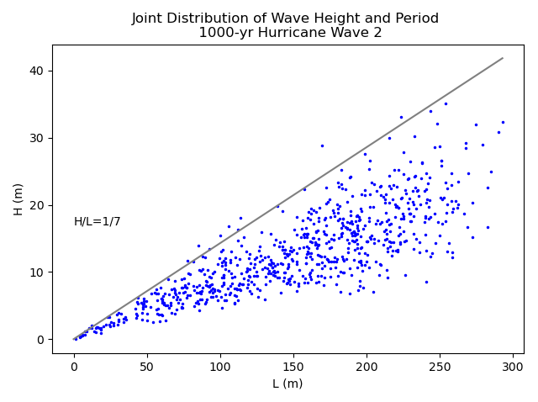

Figure 20: Wave height plotted against wavelength. Wavelength was calculated using the linear dispersion relationship with the values of T and H from Figure 16.

# **Discussion:**

Text

# **Conclusion:**

Text

# **References:**

Text